**NAME: Trent Tucker (ESC1000 12:30 TR)**

**EARTH SCIENCE - ASSIGNMENT #2 (CHAPTER 2): MINERAL IDENTIFICATION**

**DIRECTIONS: For each of the following unidentified minerals, you are provided with a photo and some physical properties. Refer to the table of “Properties of Common Minerals” (on page 2) to determine the identity of each mineral described.**

**Type your answer on the answer sheet provided on the last page (page 3) of this assignment.**

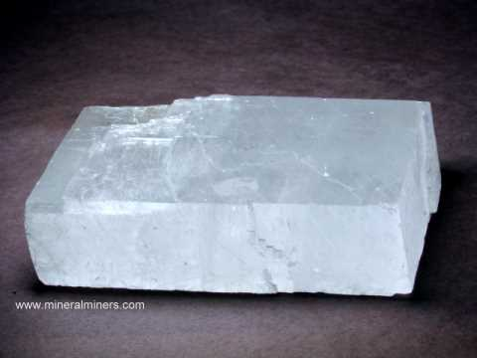**Each correct answer is worth 2 points. Due No Later Than 1:00 PM Thursday, Jan. 21st.**

**1**. **Nonmetallic Luster; Hardness: 3; Cleavage; Color: colorless to white; Other: Reacts (bubbles) with acid**

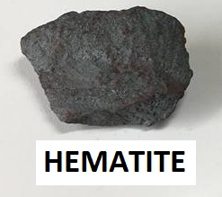

**2. Luster: Either metallic or earthy; Hardness: 5.5 to 6.5, but the earthy variety can be as soft as 1.0 – 1.5 No Cleavage; Color: metallic silver or earthy red**

**Streak: red-brown; Uses: Iron ore, paints, lipstick**

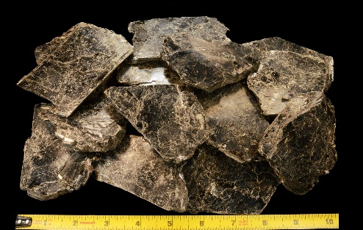

**3. Nonmetallic Luster; Hardness: 2.5 – 3; Cleavage: Thin sheet; Color: black to dark brown; Uses: Construction material**

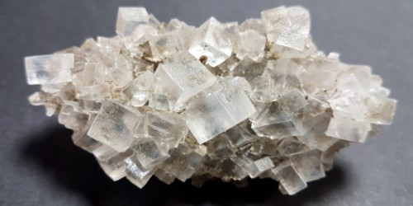

**4. Nonmetallic Luster; Hardness: 2.5; Cleavage: cubic; Color: colorless to white; Uses: Food additive, Melts ice**

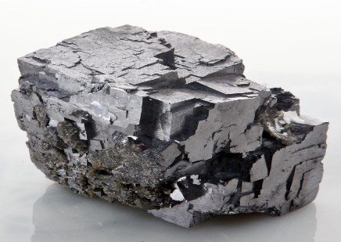

**5**. **Metallic Luster; Hardness: 2.5; Cleavage: cubic; Color: metallic silver; Streak: gray-black; Uses: Lead ore, batteries**

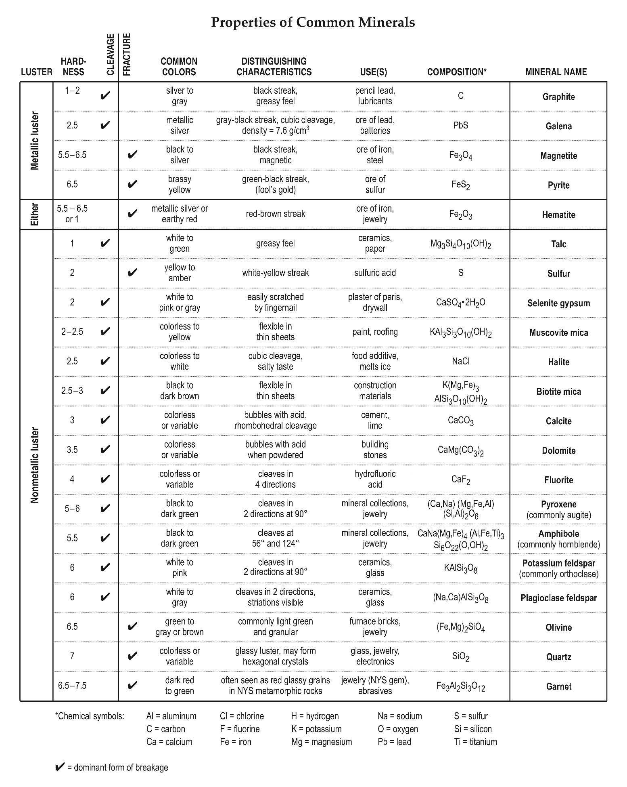

**ESC ASSIGNMENT #2 NAME:**

**Mineral Identification Answer Sheet: Type your answer (mineral name) next to each number.**

**1. Calcite**

**2. Hematite**

**3. Biotite Mica**

**4. Halite**

**5. Galena**